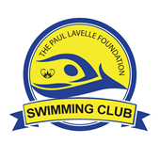
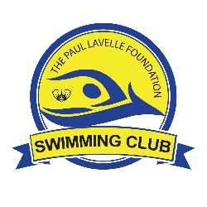
THE PLF SWIMMING CLUB DISCLAIMER

- The PLF Swimming Club exists purely to offer an opportunity for like-minded swimmers to exercise together in a group and nothing more.
- The club is operated and managed by a number of volunteers in their free time and these volunteers cannot accept any responsibility for any events that occur at the club. These volunteers may or may not have taken any training/coaching.
- All attendees should consider the club as an informal gathering of people who will run together in a loosely structured format.
- Every person attending the club must take full and complete responsibility for their own actions. Know your limits.
- If you have any medical conditions that could affect you, it’s your responsibility to make the club aware of these.
- If you feel dizzy, faint or unwell it’s your responsibility to stop exercising and to notify other swimmers of this.
- If you stop mid-session you must not go home without notifying the session leader.
- It’s your decision alone whether or not you are fit and able to swim. If you are unsure consult your physician.
- The volunteer leading the session reserves the right to refuse to let you swim with the group.
- The minimum age that we can accept is 18 unless occupied by an adult.
- Appropriate attire for swimming must be worn.
- We recommend that you with safety float and swim cap at all times
- The club does not discriminate against any attendees, but we are unable to cater for any people with special requirements.
- Each swimmers must accept full and complete liability for their actions.
- The PLF swimming club may use your photographs to share on social media. If you do not wish for this to happen please advise the club leader

COVID-19 GUIDANCE

- Your contact details must be left with the PLF representative for the purposes of COVID-19 Contact Tracing
- Should you feel any symptoms of COVID-19 you must not attend the club
- Should you come down with any symptoms of COVID-19 after attending the club you must notify us immediately.
- Please remain at the recommended social distance from other members when participating in the club activity
- Always wash your hands and use hand gel when appropriate

